[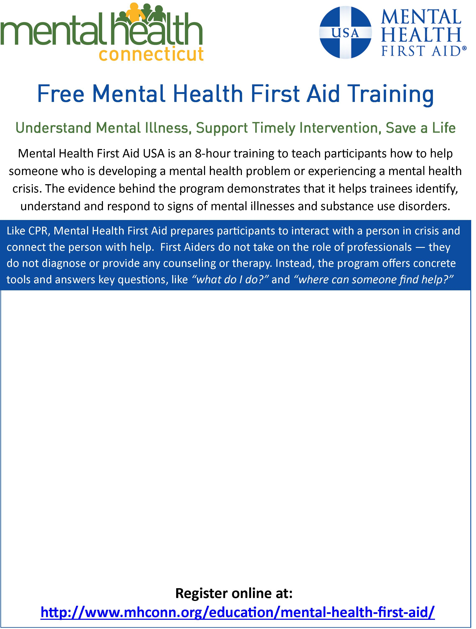](http://www.mhconn.org/education/mental-health-first-aid/)

**Date: September 12 &14, 2017 (Tues./Thurs.)**

**Time: 5:30-9:30PM**

**Location: Torrington Area Health District**

**350 Main Street**

**Torrington, CT 06790**

**Instructor: Valerie English Cooper**

**Community Educator**

**Mental Health Connecticut, Inc.**

**venglishcooper@mhconn.org**

**(860)471-6715**

**Register Online at:**

[**www.mhconn.org/education/mental-health-first-aid**](http://www.mhconn.org/education/mental-health-first-aid)