Locating an EPA Certified Renovation, Remodeling, and Painting Renovator (RRP)
As of April 22, 2010, EPA requires firms that conduct renovation, remodeling, or paint removal activities on residential houses, apartments, and child-occupied facilities built before 1978, to be:

- certified as a “certified renovator” with EPA,
- their employees must be trained in the use of lead-safe work practices, and
- the lead-safe work practices that minimize occupants’ exposure to lead hazards must be followed.

A firms’ employees must take an EPA approved 8 hour training course in order to obtain certification and become a “certified renovator”.

To locate a certified renovator with EPA:
- Go to: http://cfpub.epa.gov/flpp/searchrrp_firm.htm

- The following web page will come up:
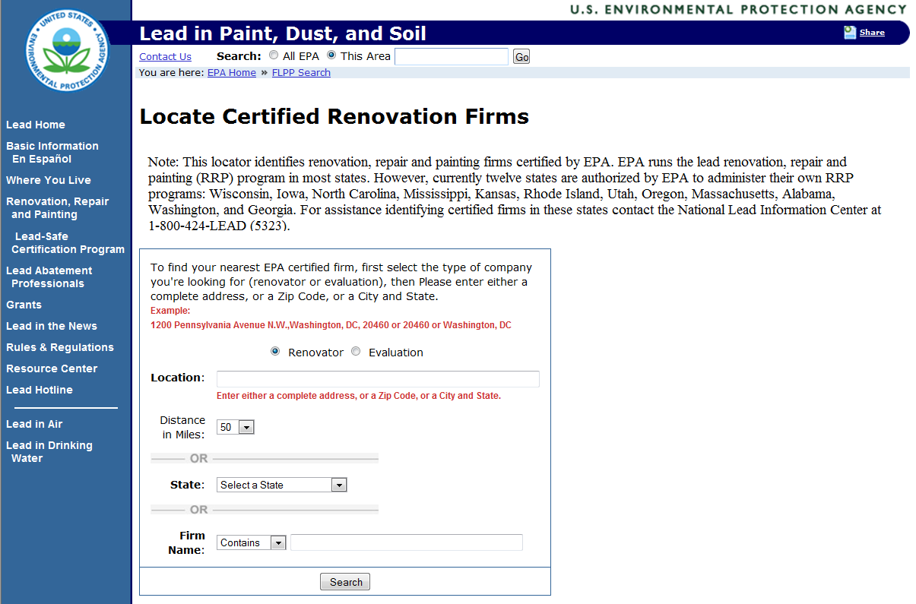
- Complete the information requested on the website and click on the “Search” button. A list of firms will be generated.

Note: If a company claims to be an EPA certified RRP renovator but does not appear on the website, you can contact the EPA directly at (617) 918-1765 or (617) 918-1607 for verification.

